**Project Tittle: Streamlining Ticket Assignment for Efficient Support**

**Team Id:** **NM2025TMID16469**

**Team Members:5**

**Team Leader: Gowri R**

**Team Member : Harini C**

**Team Member : Madhumitha S**

**Team Member : Pushkala D**

**Team Member: Afrin Banu J**

**Problem Statement:** Current ticket assignment in support teams is often manual and inefficient, leading to delays, uneven workload distribution, and reduced customer satisfaction.

**Objective:** Automate and streamline ticket assignment to the right agents.

**Skills:** Problem-solving & analytical thinking

**TASK INITIATION**

**Milestone 1 : Users**

**Activity 1: Create Users**

1. Open service now

2. Click on All >> search for users

3. Select Users under system security

4. Click on new

5. Fill the following details to create a new user

6. Click on submit

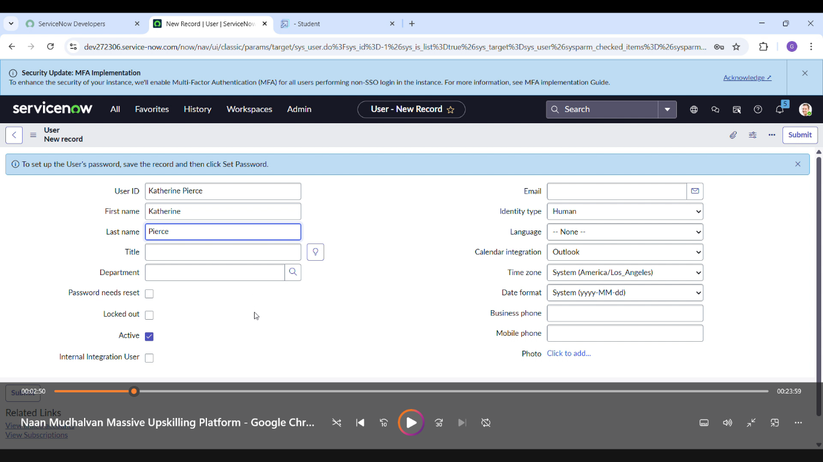

**Create one more user**

7. Create another user with the following details

8. Click on submit

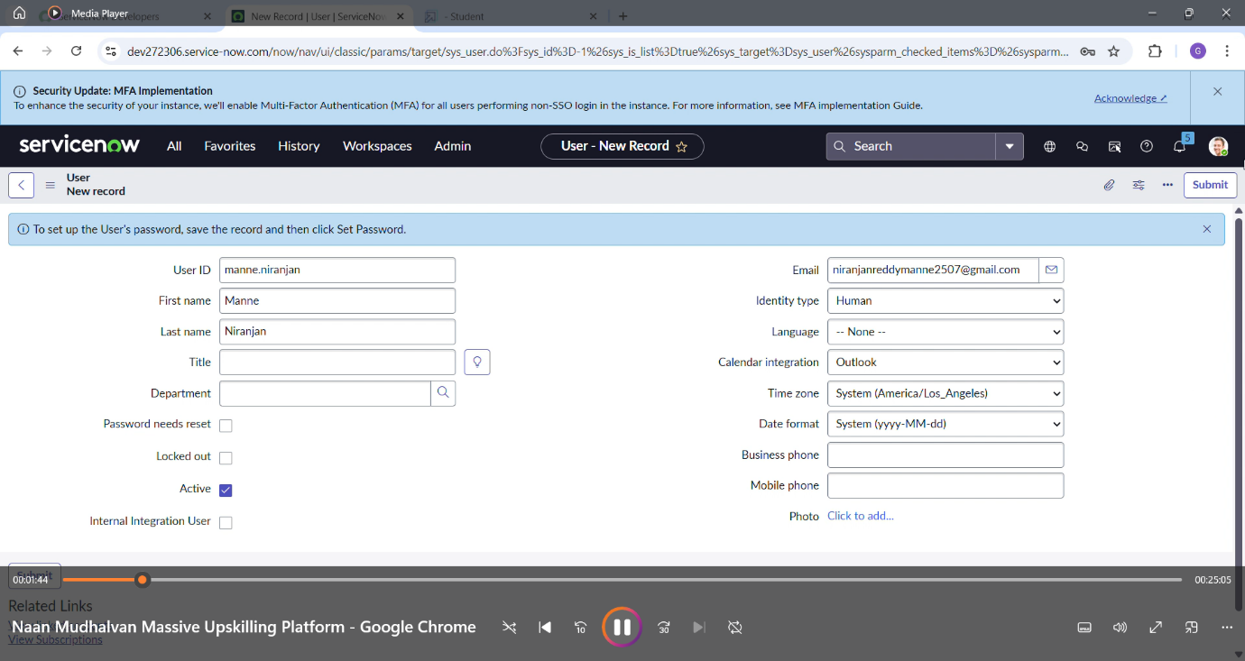

**Milestone 2 : Groups**

**Activity 1: Create Groups**

1. Open service now.

2. Click on All >> search for groups

3. Select groups under system security

4. Click on new

5. Fill the following details to create a new group

6. Click on submit

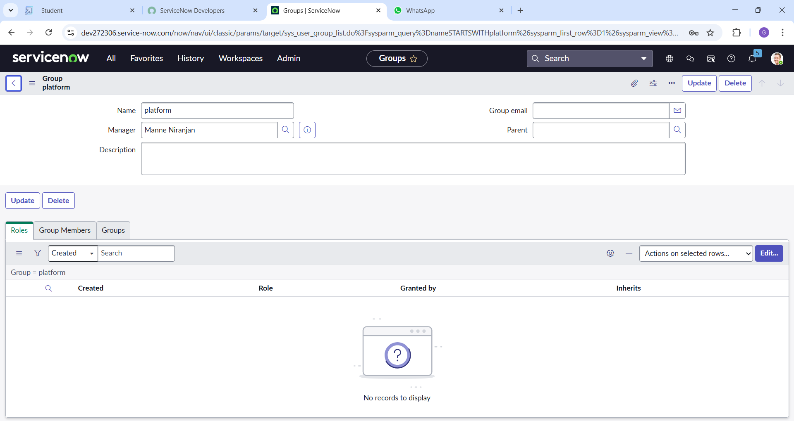 **Milestone 3 : Roles**

**Activity 1: Create roles**

1. Open service now.

2. Click on All >> search for roles

3. Select roles under system security

4. Click on new

5. Fill the following details to create a new role

**Create one more role:**

7.Create another role with the following details

8.Click on Submit

**Milestone 4 : Table Activity 1: Create Table**

1. Open service now.

2. Click on All >> search for tables

3. Select tables under system definition

4. Click on new

5. Fill the following details to create a new table Label : project table Check the boxes Create module & Create mobile module

6. Under new menu name : project table

7. Under table columns give the columns

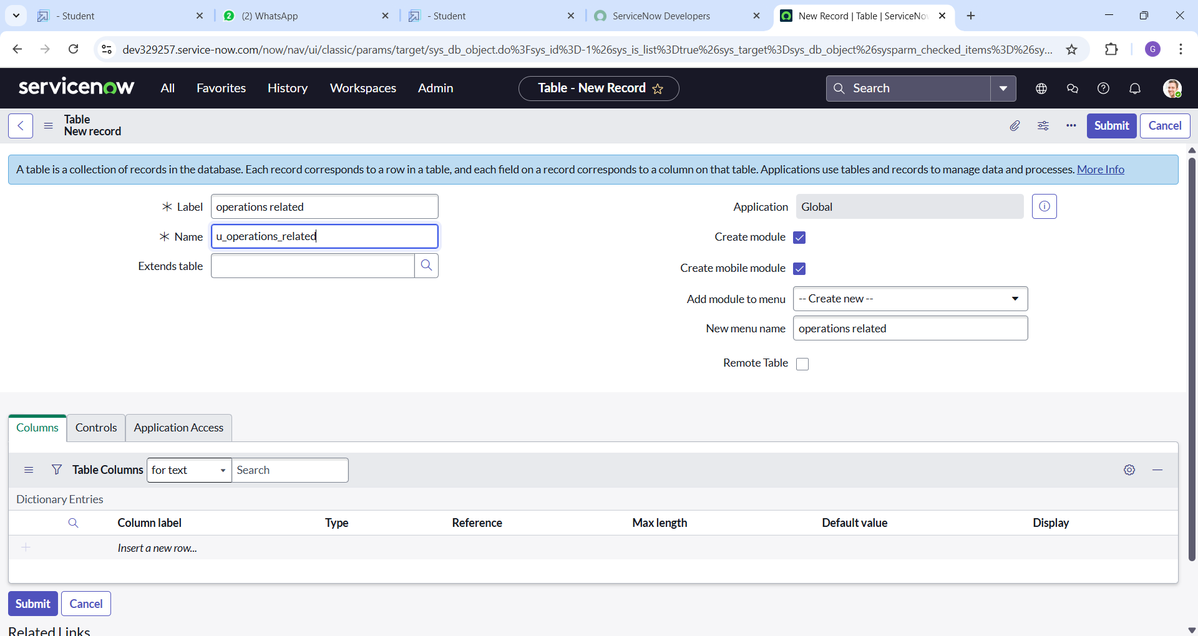 8. Click on submit

**Create one more table**:

9.Create another table as: task table 2 and fill with following details.

10. Click on submit

**Milestone 5 : Assign users to groups Activity**

Assign users to project team group

1.Open service now.

2.Click on All >> search for groups

3.Select tables under system definition

4.Select the project team group

5.Under group members

6.Click on edit

7.Select alice p and bob p and save

**Milestone 6 : Assign roles to table Activity**

1. Assign roles to alice user

1.Open service now. Click on All >> search for tables

2.Select tables under system definition

3.Select the operations related tables

4.click on the application access

5.Click elevate role

6.click on security admin and click on update

7.give platform role and add certificate role

8.click on save and update the form

**Milestone 7 :Access control list Activity 1: Create ACL**

1. Open service now.

2. Click on All >> search for ACL

3. Select Access Control(ACL) under system security

4. Click on elevate role

5. Click on new

6. Fill the following details to create a new ACL

7. Scroll down under requires role

8. Double click on insert a new row

9. Give task table and team member role

10. Click on submit

11. Similarly create 4 acl for the following fields

12.Click on profile on top right side

13.Click on impersonate user

14.Select bob user

15.Go to all and select task table2 in the application menu bar

16. Comment and state

**Milestone 8: Flow**

**Activity 1: Create a Flow to Assign operations ticket to group**

1. Open service now.

2. Click on All >> search for Flow Designer

3. Click on Flow Designer under Process Automation.

4. After opening Flow Designer Click on new and select Flow.

5. Under Flow properties Give Flow Name as “ task table”.

6. Application should be Global.

7. Click build flow.next step: 1. Click on Add a trigger

2. Select the trigger in that Search for “create record” and select that.

3. Give the table name as “ task table ”.

4. Give the Condition as Field : status Operator :is Value : in progress Field : comments Operator :is Value : feedback Field : assigned to Operator :is Value : bob

5. After that click on Done

**Next step:**

1. Now under Actions.

2. Click on Add an action.

3. Select action in that ,search for “ ask for approval ”.

4. In Record field drag the fields from the data navigation from Right side

5. Table will be auto assigned after that

6. Give the approve field as “ status”

7. Give approver as alice p

8. Click on Done.

click on activate.

**Conclusion :**

The implementation of the automated ticket routing system at ABC corporation has been a significant success.